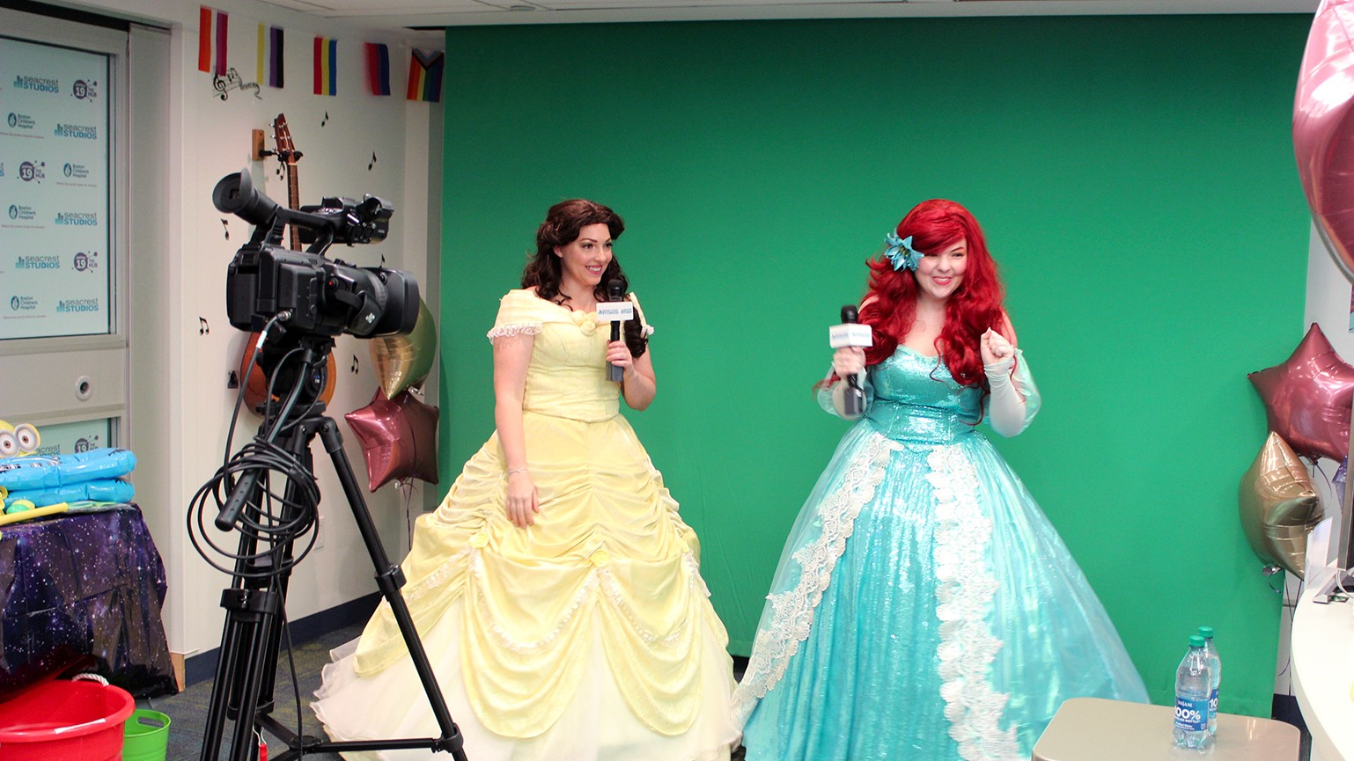Seacrest Studios brings broadcast magic to patients at pediatric hospitals nationwide with high quality audio solutions from Sennheiser
At Boston Children’s Hospital, the Ryan Seacrest Foundation’s state-of-the-art broadcast media center creates engaging content, and lasting memories, for young patients

Boston, November 29, 2023 – Since 2010, the Ryan Seacrest Foundation has built 13 state-of-the-art broadcast media centers called Seacrest Studios in pediatric hospitals across the country with support from partners including Sennheiser which provided high quality audio solutions to the studios. Seacrest Studios are available for patients to explore the creative realms of radio, television and news media, while contributing positively to the healing process for children and their families during their stay with uplifting programming and entertainment. At Boston Children’s Hospital, Seacrest Studios is broadcasting live and prerecorded television programs on Channel 19 The Hub, reaching the hospital’s three campuses in Boston, Waltham and Peabody with over 700 live, interactive shows each year. This professional broadcast operation features patient talent in the spotlight and behind the scenes, with Sennheiser’s evolution wireless G4 Wireless Microphone System at the heart of the audio setup making sure the content sounds great.

Nicole Cutinella is the Media Program Manager at the Boston Children’s Hospital outpost of Seacrest Studios. Cutinella started as a student intern in 2017, and now leads programming efforts while spearheading all large-scale technology projects in the studio, making sure that Seacrest Studios Boston is always in cutting-edge broadcast shape. “We do 3-4 hours of live programming each day, to three campuses, reaching 400 inpatient beds at medical units and outpatient areas like dialysis treatment clinics,” shares Cutinella, “all our programming is interactive here for kids at the hospital. They can be part of the show in person at the studio, or interact with us from bedside by calling, emailing, texting or Zooming in. We aim to break through isolation and create positive memories for patients. Additionally we provide one-on-one experiences for patients in the studio and offer various pre-recorded content so the channel is always on-air.”

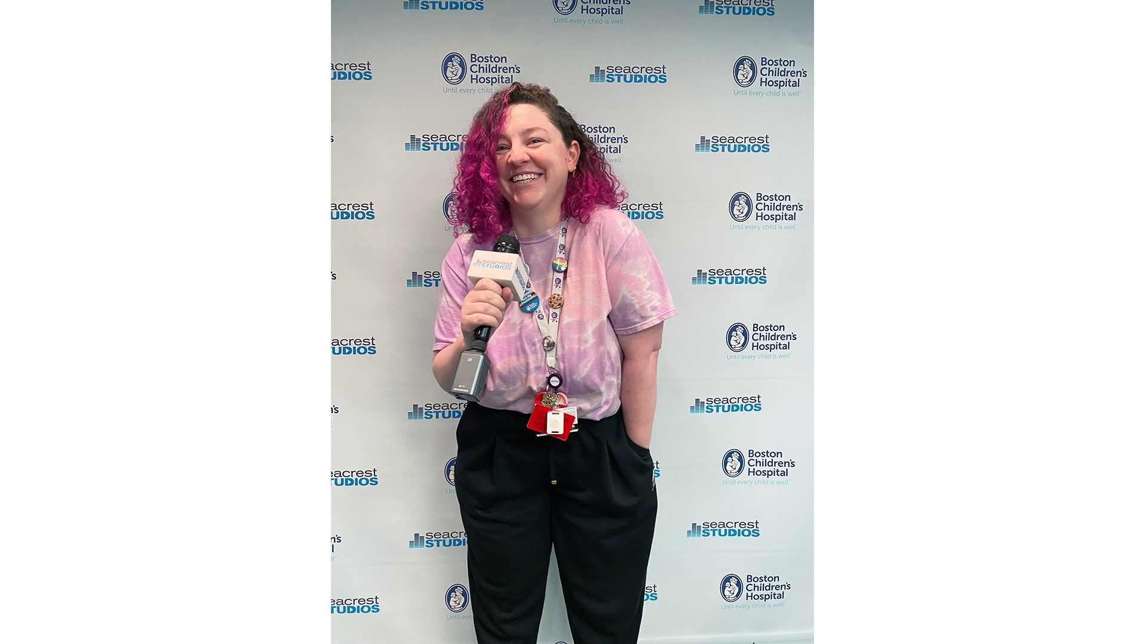 | Nicole Cutinella broadcasting live at Seacrest Studios at Boston Children’s Hospital with her trusted Sennheiser wireless mic.

Seacrest Studios has a child life specialist on staff who considers child development, and how it is influenced by the hospital environment, to create supportive programming for a diverse range of ages and abilities. Cutinella shares that bingo is the biggest runaway hit amongst the viewers, in addition to when they host celebrity guest visitors and partners, like Ed Sheeran or the Pacific Marine Mammal Center, who bring unique and memorable experiences to viewers of The Hub.

While there is something for everyone to watch on The Hub, Cutinella shares that many patients gravitate towards being on-air, “in the hospital environment where kids often have very little control, handing them the microphone and platform to be on TV can be very powerful. Some patients get a lot of satisfaction from being the star.” However, there is something for everyone at Seacrest Studios, and Cutinella and her team makes certain of that, “some patients take interest in the technology. The great thing about our equipment is that it is easy to operate. Kids can just pick it up. We’ve had 10-year-old kids teach our college interns how to use radio software. We really have something for every age range here, from babies to young adults. And if someone has an idea, we can find a way to bring it to life at Seacrest Studios.”
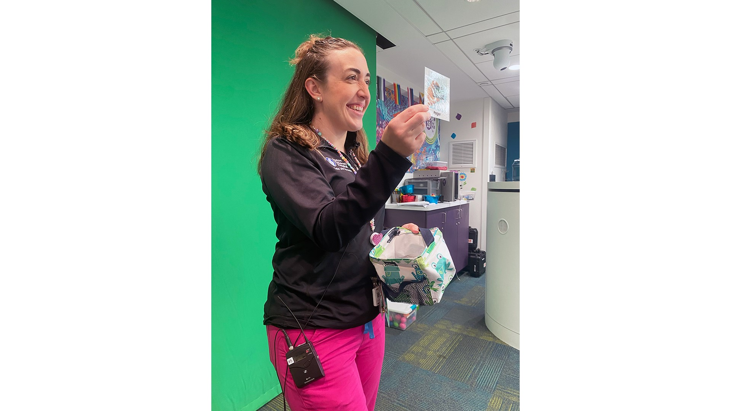 | Child Life Specialist Jamie Durkin leads an engaging game of Bingo broadcast on Channel 19 The Hub for patients.

Seacrest Studios in Boston uses a range of equipment, with 6 desktop microphones inspired by Ryan Seacrest’s radio setup, and the Sennheiser G4 Wireless System connecting the camera and on-air talent. The G4 system provides incredible flexibility for video sound and field recording applications, ensuring excellent sound quality, simple camera mounting and ease of use. The adaptable system allows the Seacrest Studios crew to switch between lavalier, headsets or handheld microphones efficiently. “Kids love the magic of holding the mic and hearing their voice come through the TV or headphones,” says Cutinella.

Seacrest Studios also uses Sennheiser HD 280 PRO headphones, which are professional mixing headphones with neutral, high-resolution sound that are frequently found in television and film production environments. With this, Seacrest Studios across the country use the classic MD 46 dynamic cardioid interview microphone, which is known for its robust, dependable sound quality in even the roughest live reporting or broadcasting conditions.

As patients at Boston Children’s Hospital have demanding care schedules and varying physical abilities, Cutinella takes pride in making sure that Seacrest Studios brings levity and joy to everyone in the hospital system. High quality, user-friendly audio solutions are a key part in achieving that goal: “the studio is so dynamic. If a patient comes in and only has 5 minutes to record a segment, then we need to be broadcast ready and the equipment needs to perform. So, we love technology that is easy to use and just works.”

“Our Seacrest Studios are able to use the best technology and equipment in the business because of support from companies like Sennheiser,” said Nicole Mead, VP, Business Development and Operations for the Ryan Seacrest Foundation. “We couldn’t continue to expand our footprint and provide such innovative and therapeutic experiences without the commitment of our technical partners.”

The Ryan Seacrest Foundation plans to continue opening in hospitals nationwide to bring the healing power of broadcast magic to pediatric patients, with three new Seacrest Studios opening in 2023 alone, and one planned for 2024. All studios are equipped with state-of-the-art broadcast gear including Sennheiser audio solutions.

For more information, visit www.ryanseacrestfoundation.org.

About Sennheiser
We live and breathe audio. We are driven by the passion to create audio solutions that make a difference. Building the future of audio and bringing remarkable sound experiences to our customers – this is what the Sennheiser brand has stood for since more than 75 years. While professional audio solutions such as microphones, conference systems, streaming technologies and monitoring systems are part of the business of Sennheiser electronic GmbH & Co. KG, the business with consumer devices such as headphones, soundbars and speech-enhanced hearables is operated by Sonova Holding AG under the license of Sennheiser.
www.sennheiser.com
www.sennheiser-hearing.com

About the Ryan Seacrest Foundation
The Ryan Seacrest Foundation (RSF) is a non-profit 501(c)(3) dedicated to inspiring today’s youth through entertainment and education-focused initiatives. RSF’s primary initiative is to build broadcast media centers — Seacrest Studios — within pediatric hospitals for patients to explore the creative realms of radio, television and new media. Founded in 2009, RSF currently has Seacrest Studios at hospitals in Atlanta, Boston, Charlotte, Cincinnati, Dallas, Denver, Orange County, Philadelphia and Washington D.C, Nashville, Orlando, Memphis and Queens. A new studio is scheduled to open later this year in Salt Lake City, UT at Primary Children’s Hospital. For more information, visit www.ryanseacrestfoundation.org.

Local Press Contact
Daniella Kohan
daniella.kohan@sennheiser.com
+1 (860) 222-4226

